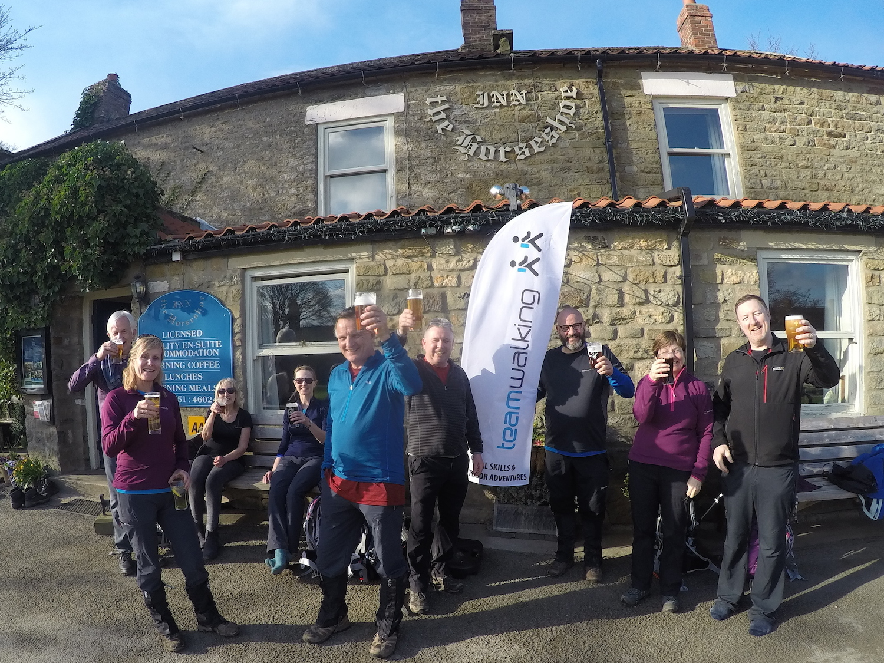
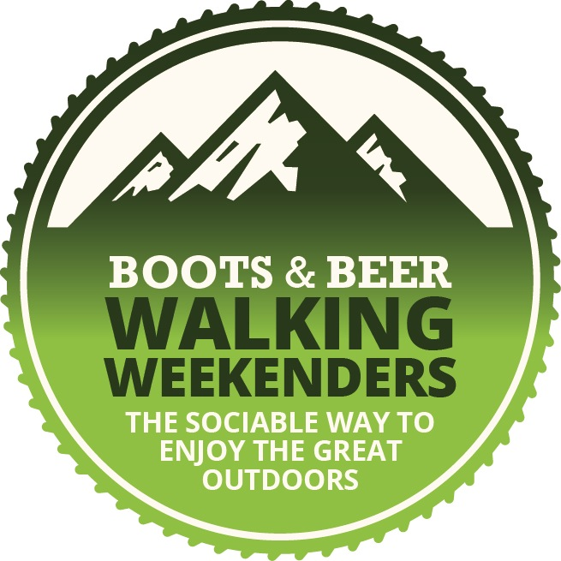

BOOKING FORM 2019

Thank you for choosing TeamWalking. I am really looking forward to meeting you and I am sure we will have an enjoyable and memorable walking weekend in the Great Outdoors!

WALKING WEEKENDERS 2019
Dates Location Price Book your place

5th - 7th April 2019 Alwinton, Northumberland £70 per person ❑
28th - 30th June 2019 Reeth, Yorkshire Dales £70 per person ❑
6th – 8th September 2019 Egton Bridge, North York Moors £70 per person ❑
18th - 20th October 2019 Patterdale, Lake District £70 per person ❑

YOUR DETAILS

Your name

Your phone number

Your email address

Postcode

Your postal address

Emergency contact
(name and ‘phone number)

Our contact details Your Walking Guide will be Mark Reid. If you or a family member wishes to contact Mark Reid before or during the activity, his mobile is 07711 264019.
WHAT TO WEAR & BRING WITH YOU

What to wear
It is important to wear a 'layering system' of clothing as follows:
- Base layer - long-sleeved T-shirt
- Mid layer – fleece
- Outer shell - waterproof/breathable coat and over-trousers
- Walking boots. These must be waterproof with good ankle support and sturdy soles
- plus walking trousers
Wear clothing that is made from synthetic fibres, which are quick drying and help 'wick' moisture away from your skin. Do NOT wear cotton (especially jeans) as cotton soaks up moisture.

What to bring
- Sunhat, sunscreen and sunglasses (weather dependent)
- Warm hat
- Waterproof gloves
- Water bottle (at least 1 litre)
- Flask of hot drink
- Spare fleece
- Packed lunch
- High energy snack food (dried fruit, nuts, muesli bars, chocolate bars etc)
- Medications (if applicable)
- Waterproof bag for your camera, mobile ‘phone etc
- Rucksack (to carry all of this in!)

Walking Boots
We recommend you provide your own waterproof walking boots with sturdy soles (with good tread) and ankle support, as these will be more comfortable than borrowed boots. We do have a few pairs of walking boots you can borrow, in sizes 4 - 12.

NEED TO BORROW SOME OUTDOOR GEAR?
We can provide the following outdoor gear:

- Waterproof outdoor Jacket (sizes S - XL)
- Waterproof over-trousers (sizes S - XL)
- Fleeces (sizes S - XL)
- Waterproof gloves (sizes S - XL)
- Hat
- Rucksack
- Head-torch
- Walking boots (sizes 4 - 12) - please use your own walking boots if you have them.

Please fill out your requirements on the participants list below.

PARTICIPANT INFORMATION: All information will be treated in confidence.

Name Age T - Shirt Size
S M L XL NO T-SHIRT (circle required size)

How often do you exercise? What regular exercise do you currently do?

X

Physical activity 0 or 1 day per week
Physical activity 2 - 4 days per week
Physical activity 5 or more days per week

NB: ‘physical activity’ means a minimum of 30 minutes of moderate
exercise, such as brisk walking, swimming, jogging, cycling etc

Describe your level of fitness When did you last climb a hill, fell or mountain?
Score yourself out of 10 (10 is high and 0 is low) (name of hill/mountain & date climbed)

Your hill-walking experience? What outdoor gear would you like to borrow?

(please give sizes)

Medical conditions, allergies, special requirements or recent illnesses
Please list all pre-existing medical conditions, allergies, special requirements or recent illnesses that may affect your participation in this activity, even if you think they may not be relevant. Please give full details of your condition(s), as this helps us provide an enjoyable and rewarding day for all. If you have a pre-existing medical condition that may make it unsafe for you to take part in this activity, then it may be necessary to seek advice from your GP. Please ensure that you bring any medication that you may need with you on your activity.

- I am aware that walking & outdoor activities have an inherent and unavoidable risk of accident or personal injury. I understand the nature of the activity I have chosen to take part in and accept the risks involved.
- I consent to emergency medical treatment or medication to be administered to me during the activity in the event of injury / accident.
- I confirm that I have a reasonable and suitable level of fitness and ability for my chosen activity.
- I confirm that the information I have provided on this Booking Form is accurate and complete.
- I undertake to inform TeamWalking of any material changes to the personal information I have provided on this Booking Form between signing this form and the day of the walk.
- By completing, signing and returning this Booking Form I confirm that I have read through, understood and accepted the Terms & Conditions detailed below, and that I am fully aware of the type of activity I will be undertaking, and I consent to my participation.

Signed (by the participant) Date

Photos & videos are taken on courses and walks, which we then send you as a memento & use on our website & social media. We never include identifying information when we publish these images. If you do not consent to this please inform Mark Reid at the start of the walk.
PRICE
£70 per person

This includes...

- Friday night 'icebreaker' evening at the pub
- Choice of walks on Saturday and Sunday
- Walks guided by qualified and knowledgeable Mountain Leaders
- Saturday evening Pub Quiz Night
- Use of our waterproof outdoor gear if required
- TeamWalking Loyalty Reward scheme
- Goodie Bag
- Boots & Beer T-shirt

Please note:
- TeamWalking is providing the guided walks and evening pub-based activities (icebreaker and pub quiz); all participants must provide their own travel, food, accommodation and walking boots.
- Over 18s only – our Walking Weekenders are designed for adults
- Choice of walks is either ‘adventurous’ or ‘leisurely’ and is dependent upon there being more than 10 participants taking part in the weekend; if there are less than 10 participants then there will be one walk per day (full day's walk on Saturday and shorter walk on Sunday).
- Loyalty Reward issued on the weekend.
- One free T-shirt per person.

Cheque attached
payable to TeamWalking

Paid online

PLEASE RETURN TO:

POST: TeamWalking, 102 Leeds Road, Harrogate, HG2 8HB

PHONE: 01423 871750 EMAIL: info@teamwalking.co.uk

Please return as soon as possible. Places subject to availability.

BOOKING TERMS & CONDITIONS IMPORTANT: please read carefully

- Hill & Mountain environment - Hill and mountain walking are adventurous activities with a risk of personal accident and/or injury. Part of the attraction of valley, hill and mountain walking is the challenge of tackling different terrains, landscapes and weather conditions; indeed, risk is often an integral part of the activity. Every effort is made to minimise potential risks & hazards; however, the very nature of valley, hill and mountain walking involves a certain level of inherent and unavoidable risk of personal accident and/or injury. The most common accident and/or injury in the outdoors include slips, trips and falls, as well as personal injury such as blisters, strained muscles, scratches & stings, sunburn, getting cold and varying degrees of personal discomfort due to weather/ground conditions (these are just examples and is not an exhaustive list). Of course, more serious accidents/injuries may occur due to the natural environment (steep, uneven, rocky, wet, slippery ground), personal health issues and extreme weather conditions. By taking part in this activity, you are aware of and accept these risks.
- All walks will involve a varying degree of uneven & rough terrain, muddy/rocky/wet ground, fields, riverside, woodland, remote open country, high ground, hills, moorland and mountainous terrain, stiles, stream crossings, roads and lanes, farms and livestock as well as a number of ascents/descents, some of which may be steep and sustained.
- Weather - We may encounter adverse weather conditions on the walk, such as strong winds, rain, mist, fog, sunshine (harmful UV), heat or cold. We may also encounter darkness and/or poor visibility. These conditions are an inherent part of outdoor activities, but may lead to varying levels of personal discomfort, such as getting cold and wet. The Walk Leader will continuously monitor weather and ground conditions, and dynamically manage the route chosen during the day to suit the group’s needs.
- The pre-planned routes may be subject to change whilst on the walk due to adverse weather conditions, pace of the group, fitness and ability levels, accidents or injuries etc. In extreme circumstances the walk may be terminated. Once the walk has commenced then any such changes to the pre-planned walk are deemed to be part of the event. The decision to change or terminate the walk lies solely with the Walk Leader.
- Walking and outdoor activities can be strenuous. Never underestimate the strenuous nature of walking particularly when this is combined with the natural environment, hill and mountainous terrain and the elements.
- Mark Reid or his freelance Mountain Leaders (Walk Leaders) accept no responsibility for personal accidents or injury or for loss or damage to personal effects unless caused by their negligence as Walk Leaders. We strongly recommend you have adequate personal insurance cover for accident or injury, as well as travel insurance in case of cancellation.
- All participants must take heed of any safety information, guidance or hazard warnings given by the Walk Leader during the pre-walk briefing or whilst on the walk.
- Fitness and Experience - Our Walking Weekenders require no previous hill-walking experience as full guidance will be given; walks are ‘pitched’ according to the experience and average fitness levels of the group. A reasonable level of fitness and ability is required as the natural environment can be demanding at times; high level hill or mountain walks will require a good level of fitness and stamina.
- All participants must provide full, complete and accurate information on their Booking Form, including any medical conditions, special requirements, allergies and/or recent illnesses; participants must inform the Walk Leader of any changes to their personal information (including medical information) that have occurred between signing their Booking Form and the day of the walk.
- All participants must provide suitable outdoor footwear, preferably walking boots, with sturdy cleated soles and ankle support.
- The Walk Leader reserves the right to refuse to take a participant whom they consider will be unable to complete the planned activity, is wearing unsuitable clothing, ignores direct safety instructions from the Walk Leader or whose behaviour falls below an acceptable standard that puts others within the group at risk.
- Alcohol, smoking & dogs - As this is an Adventurous Activity in a natural environment then we operate a no alcohol & no smoking policy during the activity. Dogs are not permitted on any of our walks. This is due to ground nesting birds, livestock & other walkers/countryside users.
- Accommodation, Food & Travel - You must book and pay for any accommodation, food and/or travel (the 'service provided') directly yourself. The contract for the service provided is between the person making the booking and the service provider.
- Payments - full payment is required prior to the outdoor course or activity (the ‘event’) to secure your booking.
- Transfer of Booking – You may transfer your booking to another advertised date (subject to availability) subject to the payment of the following transfer fees:
- Within 14 days from the date you paid for your booking (‘date of booking’) – free transfer
- After 14 days from date of booking & over 28 days before the event – additional payment of 10% of the cost of the event.
- 14 - 28 days before the event – additional payment of 25% of the cost of the event.
- 7 – 14 days before the event – additional payment of 50% of the cost of the event.
- Within 7 days of the event – additional payment of 75% of the cost of the event.
These transfer fees are payable at the time of transfer (plus any price difference). All transfers must be made prior to the event.
- Cancellations - You may cancel your booking any time within 14 days from the date you paid for your booking ('date of booking'), and we will refund the cost of your booking in full. All cancellations must be confirmed in writing by email, text or post (your refund will be sent to you within 14 days). Cancellations after 14 days from the date of booking will be subject to the following cancellation charges (which will be deducted from your refund):
- Within 14 days from the date you paid for your booking (‘date of booking’) - full refund
- After 14 days from date of booking & over 28 days before the event – cancellation charge of 25% of the cost of the event.
- 14 – 28 days before the event – cancellation charge of 50% of the cost of the event.
- 7 – 14 days before the event – cancellation charge of 75% of the cost of the event.
- 1 – 7 days before the event or non attendance – cancellation charge of 100% of the cost of the event.
- The event may be cancelled by the Walk Leader within 48 hours of the event due to adverse weather conditions or forecast. If the event is cancelled by the Walk Leader then the event will either be rescheduled for another date, your booking transferred to another advertised date or a credit note issued to be redeemed within 12 months against any TeamWalking event. The decision to cancel the event lies solely with the Walk Leader. In the event of cancellation by the Walk Leader, then TeamWalking’s liability is limited to the cost of your chosen activity only. We recommend you have adequate travel insurance in case of cancellation.
- All participants must be aged 18 years or over.

These Terms and Conditions must be read in conjunction with the Walk Overview (which can be found on our website and will also be sent to you by email), which gives more details of the chosen activity; together the Booking Form and the Walk Overview form the contract between us.

Mark Reid is a qualified Walking Group Leader, Hill & Moorland Leader and Mountain Leader, and holds a current
Outdoors First Aid certificate as well as Public and Civil Liability Insurance.

PLEASE RETURN TO: TeamWalking, 102 Leeds Road, Harrogate, HG2 8HB Places subject to availability.
(T) 01423 871750 (M) 07711 264019 (E) info@teamwalking.co.uk (W) www.walkingweekenders.co.uk

UPDATED 21st October 2018

